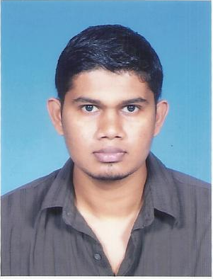**DHANUSH PERSATH MURUGAN**

A-12-03 Pangsapuri Damai Senja, Off Jalan Kelang Lama,

Petaling Utama,46200 Petaling Jaya, Selangor.

Email: [persath_0404@hotmail.com](mailto:persath_0404@yahoo.com)

Tel: 010-2592429

**Career Objective:**

To succeed in an environment of growth and excellence and earn a job which provides me job satisfaction and self development and help me achieve organization as well as personal goals.

**Educational Background:**

Bachelor's Degree of Business Studies/Administration/Management (2011)

Major : Business Administration

University : University Of Abertay Dundae, UK.

Diploma of Business Studies/Administration/Management (2011)

Major : Business Administration

University : Segi College, Kuala Lumpur

Diploma of Business Studies/Administration/Management (2007)

Major : Business Administration

University : Binary University College, Kuala Lumpur

**Employment History:**

1. Hichill Technologies Sdn.Bhd Apr 2011 - Present

Role : Administrative Executive

Industry : Chemical / Fertilizers / Pesticides

Responsibilities: All the administration work; I am in charge to prepare salary slips for the employees, responsible for and accountable, prepare letters for the companies, filling, scanning, prepare letters for visa, applications, fill up visa application forms, preparing offer/appointment and various other letters and issue them to employees.

2. Monash University Sunway Campus May 2009 - Jan 2010

Role : Data Entry Personnel –Part Time

Industry : Education

Responsibilities : Data entry for all the data of the students, key in cheques from students, manage student filing system.

3. S.A.S Eltel Sdn.Bhd May 2007 - Aug 2008  
 Role : Administrative Executive

Industry : Electrical & Electronics

Responsibilities : All the administration work; prepare bank statements, cheques, assist the manager, in charge for the employees’ salary slip, scanning, filling, prepare letters for tenders and also for the other companies.

**Skills:**

Microsoft Office, Adobe, Photo editing, video and audio editing.

**Languages:**

Spoken Written

Bahasa Malaysia 10 10

English 8 10

Tamil 10 2

**Personnel Strengths and Information:**

1. Computer Literate, multitasking skills and a fast learner
2. Sense of responsibility and undertaking
3. Good communication and interpersonal skills
4. Pleasant personality and willing to learn and adopt changes

Posses own transport: No

Expected monthly salary: RM2700 (Negotiable)

Availability: 3 weeks notice

**References:**

1.Name : Ms .Ester Mary Nagamuthu 2.Name : Mr. Vijeyenthiren

Company : Segi College Kuala Lumpur Company : Hichill Technologies sdn. bhd

Telephone: 03-20702078 Telephone: 016-3640963

Email : [estermary@segi.edu.my](http://aa.mg4.mail.yahoo.com/yab-fe/mu/MainView?.src=neo&themeName=orange&isFresh=0&bucketId=0&stab=1345682639821) Email : [vj_85@hotmail.com](mailto:vj_85@hotmail.com)